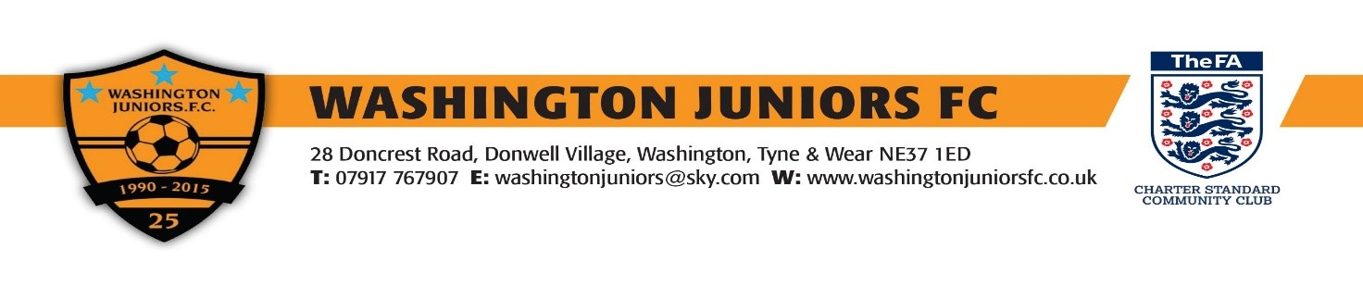

CHRISTMAS RAFFLE PRIZE WINNERS.
1st Prize £150.00 Cash Ticket No. 0656.. Big Rob Biddick Club
2nd Prize Drinks Hamper…Ticket No.1063…CLAIMED
3rd Prize £50.00 Cash…Ticket No1002…CLAIMED
4th Prize…Food Warmer…Ticket No…1020…CLAIMED
5th Prize…Bells Whisky…Ticket No…1048…CLAIMED
6th Prize…Baylus Harding Set…Ticket No…0216…Sian Metcalf Under 13s Girls
7th Prize…Next Voucher…Ticket No…0208…Gary Webster…Under 13s Girls
8th Prize…Avon Hamper…Ticket No…0115…Gillian Ayre…Under 13s
9th Prize…Baylis Hardy Therapy Set…Ticket No…0497…Rachelle Scott…under 10s Blacks
10th Prize…Magnolia Gift Set…Ticket No…1047…CLAIMED
11th Prize…Bottle of Proseco…Ticket No…0152…D Dunkley…Under 13s
12th Prize…Soap and Glory Box…Ticket No…0207…Gary Webster…Under 13s Girls
13th Prize…Bottle of Red Wine…Ticket No…0122…Earl McCartney…Under 13s
14th Prize…Mandarin Spa Set…Ticket No…0232…Paul Bond…Under 13s Girls
15th Prize…Beauticology Set…Ticket No.0200…Zena Merrigan…Under 13s
16th Prize…Happy Pamper Set…Ticket No…1398…Chris
17th Prize…Bottle White Wine…Ticket No…0315…Paul Knox…Under 11s
18th Prize…Bottle Red Wine…Ticket No…1294…Ian
19th Prize…Thorntons Chocolate Teddy and Mug…Ticket No…0138…Lesley Reed…Under 13s
20th Prize…Sweet Tree…Ticket No…1050…CLAIMED
21st Prize…Sweet Shop…Ticket No…0331…CLAIMED
22nd Prize…Skittle Blaster…Ticket No…0254…Andy…Barbour
23rd Prize…Darts Drinking Board…Ticket No…1305…J…Barbour
24th Prize…Thorntons Moments…Ticket No..0598…G Jackson PDQ…Under 11s Orange
25th Prize…Christmas Cake…Ticket No…0013…Owen Sim…Under 11s Orange
26th Prize…Belgium Chocs Thins…Ticket No…0595…Ed Phipps…Under 11s Orange
27th Prize…Thorntons Moments…Ticket No…0073…Graham Smith…Under 11s Orange
28th Prize…Maribo Sweet Box…Ticket No…1364…John Richardson…Under 13s
29th Prize…Box of Chocolates…Ticket No…0485…CLAIMED
30th Prize…Foxs Biscuits…Ticket No…1307…Tara…Barbour
31st Prize…Tin of Biscuits…Ticket No…0511…CLAIMED
32nd Prize…Butter Fudge…Ticket No…0235…Louise Bond…Under 13s Girls
33rd Prize…Girls Toy…Ticket No…0576…CLAIMED
34th Prize…Planet Spa Bath Petals…Ticket No…1373…Aimee…Under 11s
35th Prize…Fishing Fever Set…Ticket No…1018…CLAIMED
36th Prize…Selection Box…Ticket No…0171…CLAIMED
37th Prize…Frozen Crayons…Ticket No…0226…Daisy Campell…Under 13s Girls
38th Prize…Box of T Bags…Ticket No 0123…Earle McCartney…Under 13s

PRIZES TO BE CLAIMED BY END OF 2015 ON PRODUCTION OF WINING TICKET.
PRIZES CURRENTLY WITH CLUB SECRETARY.

